Truth Tables: Single Propositions and comparisons
Previously, we discussed the language of propositional logic, which concerns the logical relationship between different statements (or “propositions.”). We start by representing various simple statements with capital letters (for example, R = “Santa likes reindeer”, F = “Santa is fat,” and J = “Santa is Jolly). We can now start to look at the structure of compound statements made up of these simple statements. So, “Santa does not like reindeer” becomes ~R, while “Santa is fat and jolly” becomes F & J.
In this lesson, we’ll start learning what these “logical operators” mean, and how we can formally define them using truth tables. Then, once we have these definitions in hand, we can start using them to DO things. In particular, we can start examining the logical properties of both individual propositions, and the relationships between pairs of propositions.
- What is the purpose of constructing a truth table for a proposition? How do you determine how many rows the truth table needs to have?
- What is a logically true (tautologous) statement? A logically false (self-contradictory) statement? How do these differ from (ordinary) true or false statements?
- What is a contingent statement?
- When are two propositions logically equivalent? Contradictory? Consistent? Inconsistent?
- How can you use truth tables to determine all of the above?
By the time you have finished with the lesson, you’ll be ready to learn how we can use truth tables to deductively prove the validity of arguments.

What are Truth Tables? When are They Used?
A truth table for a compound proposition shows in every possible case how the truth value for the whole proposition depends on the truth value of the simpler components. Since a truth table needs to account for every possible combination of truth values, the number of rows depends on the number of simple propositions. In general, it will have $2^{n}$ rows, where $n$ is the number of simple propositions. For example:
- 1 simple proposition = $2^{1}=2 rows$.
  - For example, the truth table for ~R (“Richard is not nice”) would have two rows. After all, either Richard is nice or he isn’t. If he is, the statement is FALSE. If he is not, the statement is TRUE.
- 2 simple proposition = $2^{2}=2×2=4 rows$
  - For example, the truth table for $\sim R∙S$ (“Richard is not nice, but Susan is”) would have four rows. This accounts for all possibilities: (a) Both are nice; (b) both are not nice; (c) Richard is, but Susan isn’t; (d) Susan is, but Richard isn’t. This particular proposition would be true ONLY in the last of these four cases.
- 3 simple propositions = $2^{3}=2×2×2=8 rows$
  - For example, the truth table for $\left(\sim R∙S\right)⊃W$ (“If Richard is not nice, and Susan is nice, then Wallace should punch Richard in the nose”) would have eight rows.
- And so on (4 propositions = 16 rows, 5 propositions = 32 rows, …)

Constructing a Truth Table
Suppose we want to make a truth table for $A⊃(\sim B∙A)$. This has TWO simple propositions (A and B). So, we need a four-row truth table. The truth table will have one column for every operator or letter (parentheses don’t count).
- We begin by dividing the number in half (4/2 =2), and write this many Ts under the first letter (A) followed by the same number Fs: TTFF. Divide this number in half (2/2 = 1), and write this many Ts under the second letter (B) followed by the same number of Fs, and repeat: TFTF.
  - Since A occurs twice, make sure to fill out it both times exactly the same.
Sample Problem Step 1: Entering values for the simple propositions
$$A$$ | $$⊃$$ | $$(\sim$$ | $$B$$ | $$∙$$ | $$A)$$
T |  |  | T |  | T
T |  |  | F |  | T
F |  |  | T |  | F
F |  |  | F |  | F
- We know follow the order of operations, and fill out the truth values for each columns.
  - Start with the “~” next to B. This has the opposite truth value as B: FTFT.
  - Go to the “$∙$” between ~B and A. This is true only when BOTH of these are true (on the second line). Every other line is false.
  - Go to the main operator, which in this case is a “$⊃$”. This is false only when A is true AND $(\sim B∙A)$ is false (on the first line). Every other line is true.
Sample Problem Step 2: Filling out the rest of the truth table
$$A$$ | $$⊃$$ | $$(\sim$$ | $$B$$ | $$∙$$ | $$A)$$
T | F | F | T | F | T
T | T | T | F | T | T
F | T | F | T | F | F
F | T | T | F | F | F
Step 3: Evaluating Propositions Using Truth Tables. In order to evaluate the logical status of the proposition, we need to look at the truth values under the main operator (in this case, the $⊃$ following the A).
- If every truth value under the main operator is a “T”, the statement is tautologous (or logically true). This means that it is impossible for this statement to be false, regardless of what it “means.” (Some example tautologies would be $(A∨\sim A)$ or $\left(B⊃B\right).$
- If every truth value under the main operator is an “F”, the statement is self-contradictory (or logically false). This means that it is impossible for this statement to be true, regardless of what it “means.” (Some example self-contradictory statements would be $(A∙\sim A)$ or $(B≡\sim B).$
- If the statement has some Ts and some Fs, the statement is contingent—it’s truth value depends on what it “means.” For example, $(A∨B)$, $(A⊃B)$, and $(A∙B)$ are all contingent.
The truth table constructed above shows that $A⊃(\sim B∙A$. is an example of a contingent statement. (There is at least one T AND at least one F in the column under the main operator.)

Using Truth Tables to Compare Propositions
We can also use truth tables to compare propositions. For example, suppose want to compare $A⊃B$ with $A∙\sim B.$ We need a four line truth table, and write the propositions next to each other. We fill it out as before, writing TTFF under A and TFTF under B. We then fill out the rest of table, starting with the “~”, and moving on to the “$⊃$” and “$∙$”. There are TWO main operators (one for each proposition).
Sample table: Comparing two propositions
$$A$$ | $$⊃$$ | $$B$$ |  | $$A$$ | $$∙$$ | $$\sim$$ | $$B$$
T | T | T |  | T | F | F | T
T | F | F |  | T | T | T | F
F | T | T |  | F | F | F | T
F | T | F |  | F | F | T | F
In order to evaluate the relationship between the propositions we are comparing, we need to look at the column under each of the main operators.
- Determine whether they are equivalent, contradictory, or neither.
  - If the truth values in the two columns are exactly the same, the statements are logically equivalent.
  - If the truth values in the two columns are exactly the opposite (in terms of T and F), the statements are contradictory.
  - Otherwise, they are neither.
- Determine whether they are consistent or inconsistent (they must be one or other other).
  - If there is at least one row where columns are “true”, then the two propositions are consistent (they both “could be true at the same time.”)
  - If there is NOT any row where both columns are “true”, then the two propositions are inconsistent (they cannot “both be true at the same time). All contradictory pairs of statements are also inconsistent.
The example here is both contradictory and inconsistent.

Solved Problems
Problem 1: Construct truth tables to determine whether the following statements are tautologous, self-contradictory, or contingent. (Note that the notation here for the logical operators is a bit different than what we’ve been using. This is due to the software used to produce the truth tables).
Statement | Truth Table | Judgement
(P ∙ ~Q) ⊃ P | 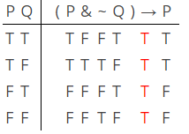 | This is tautologous, since EVERY line under the main operator is a T. This means that the statement will be true no matter what the world happens to be like. More specifically, it will be true regardless of the truth of the simple statements P and Q that make it up.
(P v Q) ⊃ P | 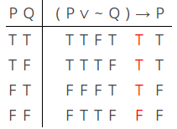 | This is contingent, since there is at least one row under the main operator that is true (in fact, the first three rows are true), and one row that is false. This means that the truth or falsity of this statement depends on what the world is actually like, and can’t be determined simply by examining its logical form.
(A ∙ ~B) ≡ ~~B | 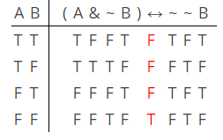 | This is another contingent statement. This time, there are more “Fs” than “Ts” under the main operator, but this doesn’t matter. The only thing that does matter is that there is a mix of Ts and Fs.
[(T ∙ U) ⊃ Z] ≡ [(U ∙ T) ∙ ~Z] | 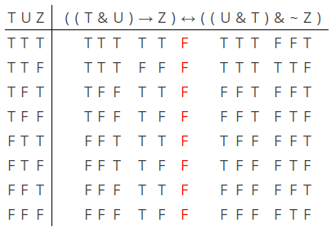 | This is a self-contradictory statement: as you can see, this statement will ALWAYS false, regardless of the individual truth values of T, U, and Z. (So, it doesn’t matter what T, U, and Z happen to mean, or what the world is like, etc.) The main operator here is the ≡ in the middle: notice that there are only Fs underneath it.
Problem 2: Use truth tables to determine the logical relationship between the following pairs of statements.
Statement 1 | Statement 2 | Truth Table | Judgement
R ⊃ ~O | ~R ⊃ O | 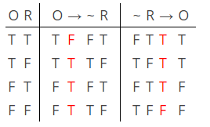 | These two statements are logically consistent, since there are some rows (the 2nd and 3rd rows, in this case) where they are both TRUE. However, they are NOT logically equivalent, since there are some rows (the 1st and 4th) where they have different truth values.
S v ~~D | D v S | 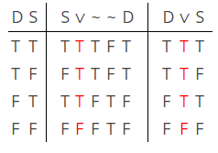 | These two statements are logically consistent (they are both true in rows 1 through 3). They are also logically equivalent, since their main operators have the exact SAME truth value on every line. Basically, these are just two ways of saying the exact same thing.
~Y & ~ R | Y v R | 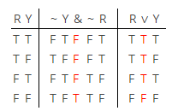 | These statements are mutually inconsistent. The reason for this is that there is no row in which both of them are true. So, for example, in the first three rows, the first statement is false. It is true in the fourth row, but the other statement is false.  Since these statements have exactly OPPOSITE truth values on every row, the statements are also contradictory.

Review Questions
- How many rows would be needed to construct truth tables for the following compound propositions?
  - ~A
  - A v ~A
  - B ⊃ A
  - A ≡ (B ∙ ~C)
  - ~(A ∨ C) ⊃ (D ∙ E)
- Construct a truth table for the following compound propositions. Then, say whether they are contingent, tautologous, or self-contradictory.
  - D ⊃ (C ∨ D).
  - ~C ≡ (C ∙ ~D)
- Construct a truth table to compare the following pairs of propositions. Determine whether they are equivalent, contradictory, or neither, and whether they are consistent or inconsistent.
  - A ∙ ~B and ~A ≡ B.
  - ~A ∨ B and A ⊃ B

